“TCP wrapper for sshd”

**Task 2. Configure TCP Wrappers**

1. Create and run a script (Ansible playbook) to configure TCP Wrappers so that SSH service on a test VM will be accessible only from your host machine and the test VM.
2. Write a report in Google Doc providing the playbook’s code and proof of workability (screenshots or asciicinema recording)

Target platform: any Linux-based distribution

Solution:

To create a TCP wrapper for SSH service (sshd) we need to add needed rules to two configuration files in /etc folder : /etc/hosts.allow and /etc/hosts.deny. We can do it in two ways:

* using lineinfile ansible builtin module
* using shell module and shell commands

I used Ansible roles to have reusable code for this task.

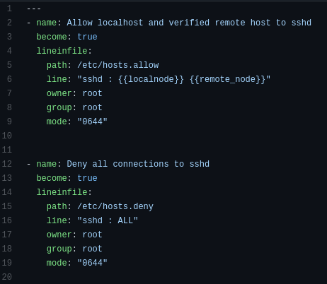

Code of roles/tcp_wrapper/tasks/main.yml using lineinfile module



Code of roles/tcp_wrapper/vars/main.yml using lineinfile module

The second way using shell commands:



Code of roles/tcp_wrapper/tasks/main.yml using shell



Code of tcp_wrap_playbook.yml (common for both ways)

The full code you can find in the github repository: <https://github.com/andrikstravinsky/GLBaseCamp2021>

The results after running playbook:

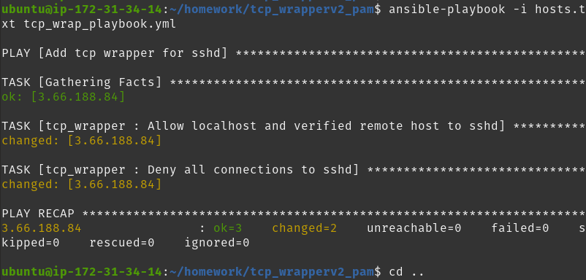

The result after running a playbook using lineinfile module

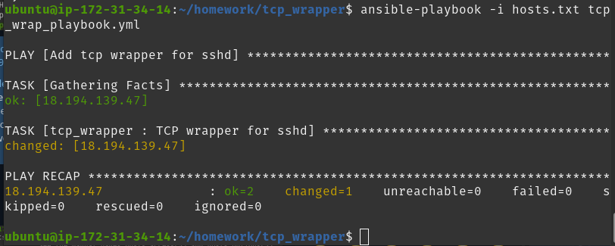

The result after running a playbook using shell commands

Files /etc/hosts.allow and /etc/hosts.deny on the target host after running playbook (the result was identical for both ways, before testing second way files were reset):

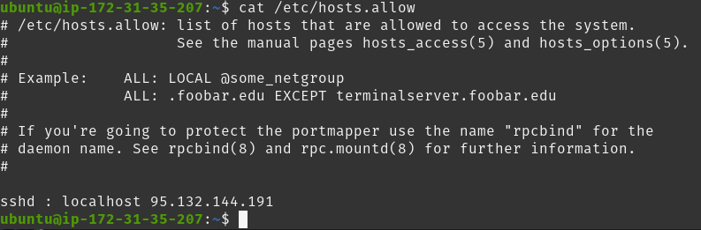

/etc/hosts.allow

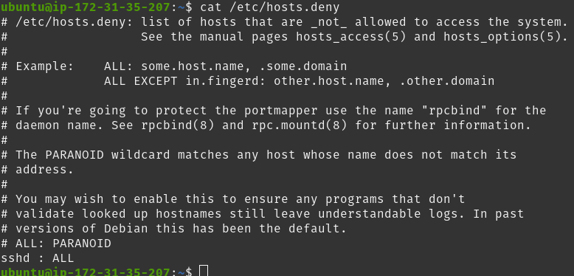

/etc/hosts.deny

To test the task I tried to connect to the target host via ssh from my “whitelisted” host, from another linux host not included in the wrapper rule and locally on the target host (localhost).



Connection from my “whitelisted” host 95.132.144.191

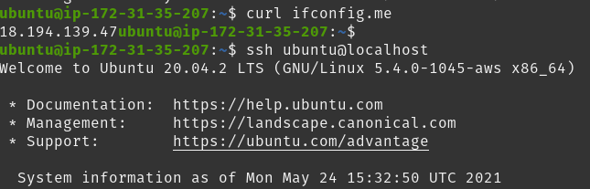

Connection from localhost

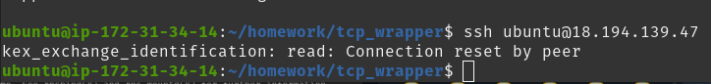

Connection from not whitelisted host 35.156.130.206 and error message